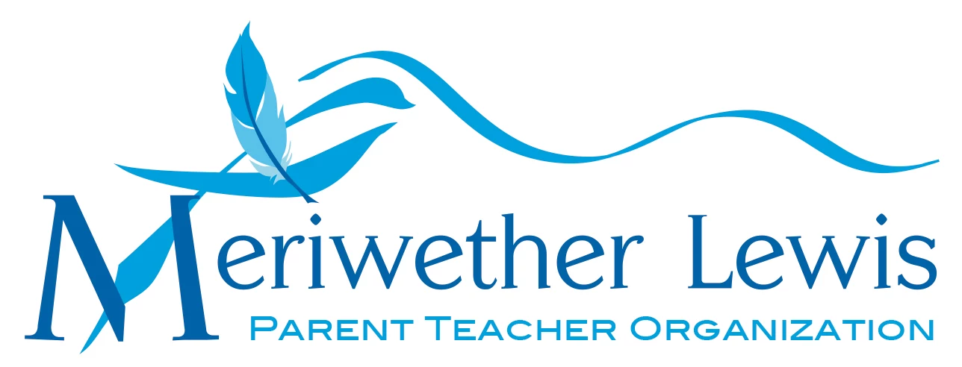
Parent/Teacher Suggestion Form for
PTO Funding & Planning

PTO funds are allocated for the benefit of Meriwether Lewis Elementary in three main ways:
1.) via strategic funding priorities set out by the Annual Fund, 2.) directly from the approved PTO budget, and 3.) through year-end funding decisions that occur after our PTO programs are completed for the school year. We welcome ideas from faculty, staff, and parents for immediate expenditures as well as budget additions and Annual Fund initiatives for 2019-2020.

If you have a funding suggestion you would like to share, please return this form by Tuesday, May 14th, either via backpack mail or by emailing the pertinent information to Carrington Grossman and AmyLynn Johnson at president@mlspto.org. Please fill out every section below, including cost, so that we may properly evaluate this suggestion and discuss viability with MLS administration. Feel free to attach additional sheets as needed.
Thank you for sharing your ideas!

Your name: ____________________ _________________

Phone: __ ___________ Email: ____________________________________

Description of project(s)/program(s)/item(s):

How it benefits students and/or their learning experience:

Specific items suggested and estimated cost:

